8.Sort an array of integers using the bubble sort technique. Analyze its time complexity using Big-O notation. Write the code.

CODE:

#include <stdio.h>

int main() {
int n, i, j, t, swapped, a[100];
scanf("%d", &n);
for (i = 0; i < n; i++) scanf("%d", &a[i]);
for (i = 0; i < n - 1; i++) {
swapped = 0;
for (j = 0; j < n - i - 1; j++) {
if (a[j] > a[j + 1]) {
t = a[j];
a[j] = a[j + 1];
a[j + 1] = t;
swapped = 1;
}
}
if (!swapped) break;
}
printf("Sorted array: ");
for (i = 0; i < n; i++) printf("%d ", a[i]);
printf("\n");
return 0;
}

OUTPUT:

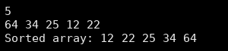
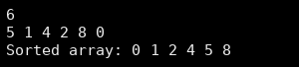

Time Complexity Analysis:
Worst case (array in reverse order): (n-1) + (n-2) + ... + 1 = n(n-1)/2 comparisons and swaps, so O(n²).
Average case: O(n²).
Best case (already sorted): with the swapped flag the loop stops after one pass, so O(n).
Space Complexity: O(1), because the array is sorted in place.

